Stroke detection using Machine Learning

Mohamed Elramy
Department of Computer Science
at Modern Academy Maadi
mmelramy10@gmail.com

Abdelrahman Elneel
Department of Computer Science
at Modern Academy Maadi
mmelramy10@gmail.com

Mohamed Tarek
Department of Computer Science
at Modern Academy Maadi
mmelramy10@gmail.com

Abanoub Tarek
Department of Computer Science
at Modern Academy Maadi
mmelramy10@gmail.com

Waled Yaser
Department of Computer Science
at Modern Academy Maadi
mmelramy10@gmail.com

Abstract— Technological advancement has a profound effect on all spheres of life, especially in the medical field. Artificial intelligence has shown promising results in health care by supporting clinical decisions through data analysis and pattern recognition. For life-threatening conditions, the most critical step in improving patient outcomes is early diagnosis. Stroke is a major global health problem and one of the leading causes of death and long-term disability worldwide, making timely detection essential. With the increasing use of digital health technologies, extensive medical data related to stroke risk factors and symptoms has become more accessible and can be leveraged to enhance diagnostic accuracy. In this project, we compare the performance of various machine learning algorithms for predicting stroke occurrence and select the model with the highest accuracy for final evaluation and deployment.

Introduction
In recent years, stroke has emerged as one of the leading causes of death and long-term disability worldwide. According to the World Health Organization (WHO), stroke occurs when the blood supply to part of the brain is interrupted or reduced, preventing brain tissue from receiving oxygen and essential nutrients. Symptoms can appear suddenly and may include weakness on one side of the body, difficulty speaking, loss of balance, severe headache, or confusion. Individuals with underlying conditions such as hypertension, diabetes, heart disease, or high cholesterol face a significantly higher risk of experiencing a stroke.
Due to the critical importance of early detection and intervention, developing a system capable of predicting stroke risk has become increasingly necessary. With the growing availability of medical and behavioral data, machine learning methods provide effective tools for identifying patterns associated with stroke and supporting timely diagnosis. Machine learning classification algorithms, structured datasets, and advanced analytical software play a key role in designing a reliable stroke prediction model.
This project aims to compare different machine learning algorithms such as K-Nearest Neighbors, Random Forest, and Naive Bayes in terms of their prediction accuracies. After evaluation, the most effective algorithm—XGBoost—was selected to build the final system, which predicts whether an individual is at risk of stroke based on the input features provided to the model.
Related Work
A strong and accurate diagnosis of stroke can save thousands of lives each year and provides a substantial amount of clinical information on which machine learning (ML) models can be trained. ML can offer valuable support in this regard, especially for diagnostic decision-making based on clinical literature, patient health records, and medical imaging such as CT or MRI scans. Studies in [3] demonstrated the effectiveness of machine learning approaches in distinguishing stroke patients with high accuracy using support vector machine (SVM) algorithms. The study analyzed patient data collected from a major medical center specializing in neurological emergencies. The research team evaluated the performance of several ML models—including neural networks, gradient-boosted trees, random forests, logistic regression, and SVM—on predicting stroke occurrence from clinical and demographic data.
Similarly, the study in [4] applied classifiers such as logistic regression, multilayer perceptron (MLP), and XGBoost on a structured stroke patient dataset obtained from a large hospital database [9]. Their approach achieved classification accuracies above 90% in identifying patients at risk of stroke. The work in [5] developed and evaluated an ML-based diagnostic tool for stroke prediction using demographic variables, laboratory features, and known risk factors. The dataset used in their study was collected from a regional health system and included emergency room and inpatient cases assessed for stroke. The researchers tested several ML models and ultimately used an ensemble of the best-performing algorithms. Their system demonstrated strong predictive capability, with high sensitivity and specificity for early stroke detection.
Additional research in [7] reported stroke prediction performance with accuracy and recall scores above 89%. In [6], machine learning models were used not only to predict stroke but also to estimate the likelihood of requiring intensive care, achieving over 95% accuracy in critical outcome prediction. Despite these advancements, limited work has focused on applying machine learning techniques to structured text-based clinical reports for stroke diagnosis. Therefore, in this study, we utilize multiple machine learning models to classify clinical records as indicating stroke or non-stroke conditions.
The proposed methodology consists of four key steps. Step 1 involves data collection, while Step 2 provides an overview of preprocessing techniques applied to the raw dataset. Step 3 includes exploratory data analysis to better understand the characteristics and distribution of the data. Finally, Step 4 focuses on hyperparameter tuning using Grid Search CV to optimize model performance.

- Data Collection

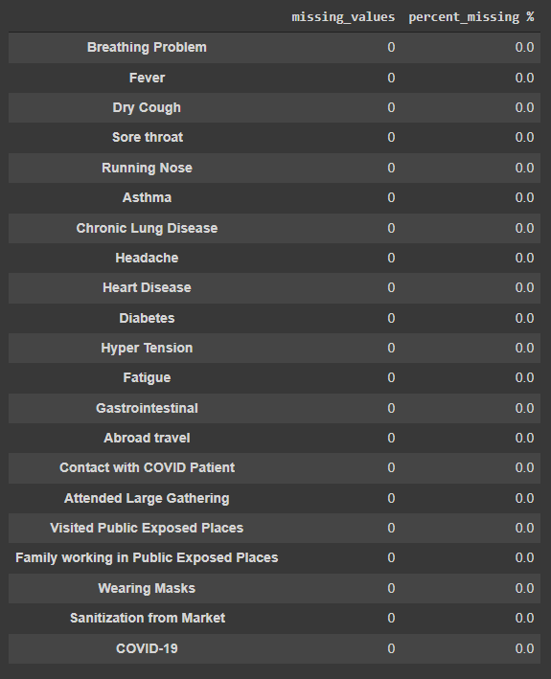
As the WHO has declared the Coronavirus pandemic as a health emergency, researchers and hospitals have provided open access to data related to the epidemic. We procured a data set from kaggle.com and it has 5434 × 21 rows of columns. This dataset contains 20 variables that could be determinants in the prediction of COVID-19, as well as one class attribute that defines if COVID-19 is found.

- Data Preprocessing
The process of converting raw data into a comprehensible format is known as data preprocessing. Real-world data may have noise, missing values, or be in an incompatible format that prevents it from being directly used in machine learning models. Preprocessing of data is an essential step in which we clean the data and make it compatible i.e. suitable to be used in a machine learning model. This also enhances the accuracy and efficiency of the model. The main steps in data preprocessing are as follows:

  - Removing features: From the figure 2 we can conclude that wearing masks and sanitization from the market are two features that have only one value that is ‘no’ as they don’t affect our predictions we can simply just drop those columns off our dataset.

  - Encoding Categorical Data: Labeling Coding is a popular form of code flexible code management for categories. In this process, each label is given a whole number based on alphabetical order. All attributes of our dataset are of ‘yes’ or ‘no’ type so we have used label encoding to convert it to 0 and 1 for the model to understand the dataset better. Table 4 shows the dataset after applying label encoding.

  - Splitting the Dataset: The next stage in machine learning data preprocessing is to split the dataset. A machine learning model’s dataset should be split into two parts: training and testing.
We divided the data into an 80:20 split. This means that we use 80% of the data to train the model while keeping the remaining 20% for testing. We take all the 20 independent attributes into x and the dependent column ‘COVID-19’ into y as we aim to predict if the patient is COVID positive or not.

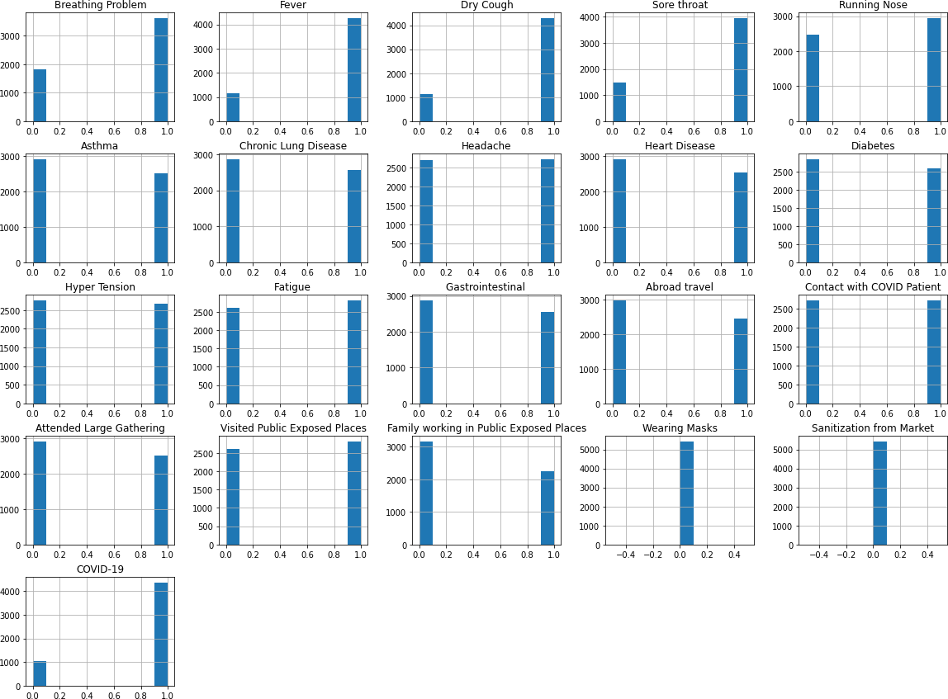
- Exploratory Data Analysis
Exploratory data analysis is used to evaluate various datasets with the aim of summarizing them based on their key char- acteristics. This summary can be visualized using statistical graphics and other data visualization techniques. EDA helps data scientists in different ways:-
- Increasing the understanding of data
- Detecting a variety of data patterns
- Improved comprehension of the problem statement

- Hyperparameter tuning by grid search CV
Its main goal is to discover the optimal parameters where the model’s efficiency is the best or highest and the error rate is the minimum. We have used the gridsearchcv tool to produce the best combination of parameters, based on accuracy score as the scoring metric when all the different parameters are fed into the parameter grid.
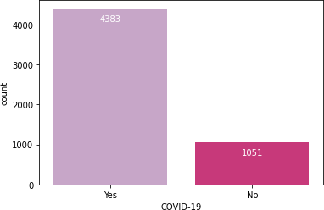

Fig. 3. Histogram showing the number of patients with covid positive and negative

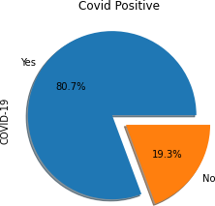

Fig. 4. Piechart showing the number of patients with covid positive and negative

- Implementation
With the growth of computer technology, predictive mod- eling is changing. We are now able to make predictable modeling more efficient, and less expensive than before. In our project, we use various classification algorithms to predict and use a grid search CV to find the most advanced solution for each algorithm. Some of the categorization algorithms that have been employed include:
- Logistic Regression
Logistic regression is a data categorization technique that uses machine learning. This algorithm, models the odds of
the potential outcomes of a single experiment using a logistic function. The easiest way to understand the influence of numerous independent factors on a single outcome variable is to use logistic regression, which was designed for this purpose. In general, the algorithm calculates the probability of belonging to a particular class. We have two classes here, y=0,1.

- K Nearest Neighbors
The oldest supervised machine learning algorithm for classification is KNN, which classifies a given instance according to the majority of categories among its k-nearest neighbours in the dataset. The distance between the item to be categorized and every other item in the data set is calculated by the algorithm.

- Random Forest
This classifier is a meta-estimator that adapts to decision trees on the dataset’s different sub-samples and utilizes the average to increase the model’s predicted accuracy and control over-fitting. In most circumstances, this random forest classifier seems to be more accurate than decision trees, and it also minimizes overfitting. At the Random Forest level, average over all the trees is the final feature importance. The feature’s importance sum value on each tree is numerically calculated and divided by the total number of trees:

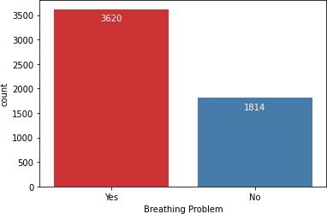

Fig. 5. Histogram showing the number of patients having breathing problems

- Result and Discussion
To evaluate the effectiveness of the Machine Learning algorithms applied in this experiment, we decided to adopt the Accuracy, Mean squared error, Precision, Recall and F-Measure which are widely used in domains such as information retrieval, machine learning and other domains that involve binary classification.

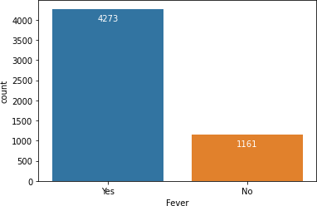

Fig. 6. Histogram showing the number of patients having fever

Figure 7 shows that all of the algorithms performed well during the training process, owing to the fact that the hyperparameters had been fine-tuned. However, there were minor discrepancies in accuracy, as indicated by the blue bar. The Random Forest Tree method has the best accuracy of all the algorithms, with a score of 98.39 percent. Additionally, R2 scores, mean squared errors and ROC scores are plotted in the bar chart using red, green and purple respectively. With
98.37 percent accuracy, the KNN is the next most acceptable algorithm to use.

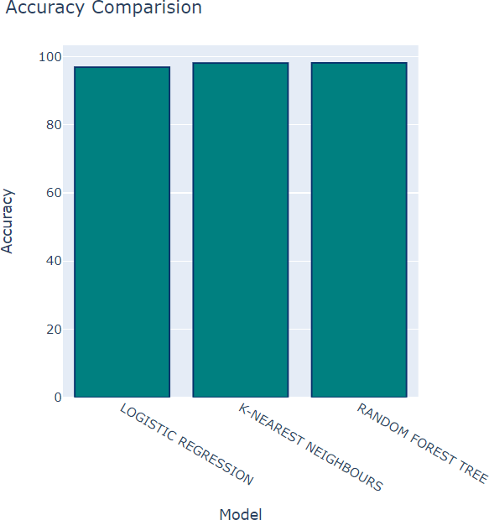

Fig. 7. Analysis of algorithms by their accuracy

The Mean Squared Error gives the difference between the expected value of the class and the actual class. This allows us to see how well the built model estimates the labels of the samples in comparison with the original values in the dataset. A low MSE model can be considered to be more efficient

Fig. 8. Analysis of algorithms by time taken for fitting the model
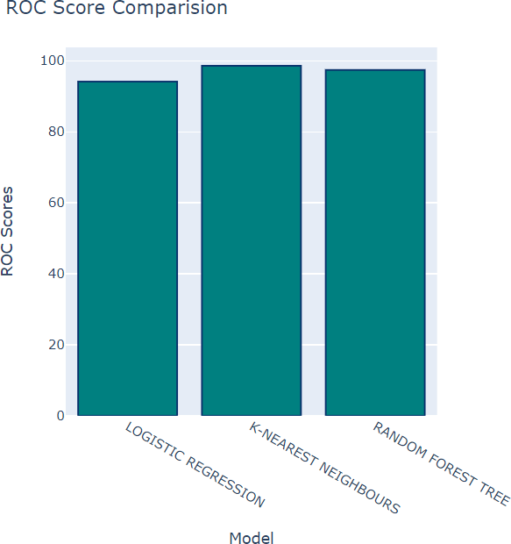

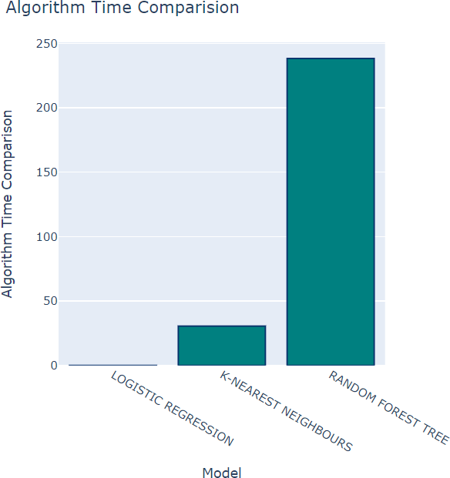
Fig. 9. Analysis of algorithms with ROC score

compared to a model having high MSE. The lowest MSE was attained by the Random Forest algorithm, with 2.207% followed by KNN having 2.57%.

R2 scores measure how well the model fits over the data. So here we see that Random Forest have the highest score of 85.51% followed by KNN with 83.1%. Finally, as shown in Figure 10, the time it took to develop the model was taken into account, as this is an important factor in determining the

 | Accuracy | MSE | R2 score | ROC  score | Running  time
KNN | 98.37% | 2.57 | 83.1 | 98.58 | 24.252
Logistic Re-  gression | 97.03% | 3.036 | 80.086 | 93.23 | 0.038
Random For-  est | 98.39% | 2.207 | 85.51 | 97.41 | 213.331

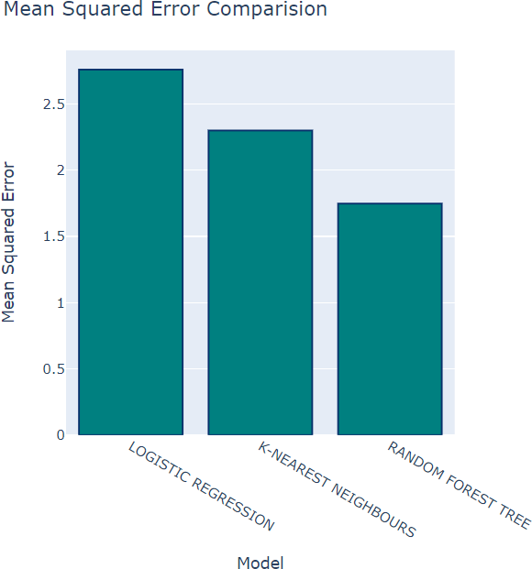
Fig. 10. Analysis of algorithms with MSE
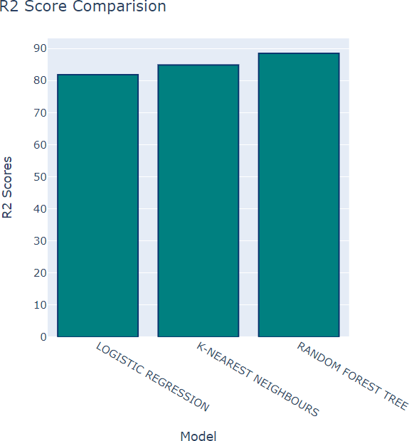

Fig. 11. Analysis of algorithms with R2 score

best algorithm for our prediction model. Based on the results, Logistic Regression was the fastest algorithm with 0.05s to train a classifier model.

- Conclusion
The goal of this work was to use the three supervised machine learning techniques to create a COVID-19 presence predicting model. The model’s performance was evaluated
TABLE I
Comparison of metrics for KNN, Logistic Regression and
Random Forest

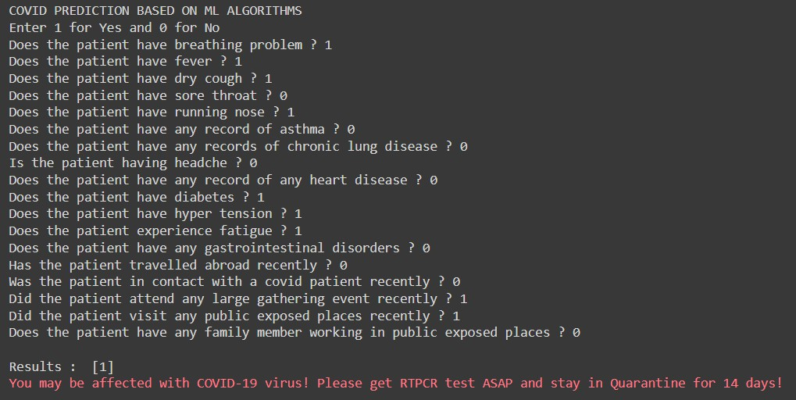

Fig. 12. Prediction model takes input from the user and gives a result -
COVID Negative

in a comparative analysis. The results show that the KNN classifier with number of neighbors to be considered equal to 2 is the best machine learning algorithm, having an accuracy of 98.37%, and 0.026 mean absolute error considering the runtime for training. In comparison to other methods, the model takes average time but gives good accuracy.

This research can be used as a supporting tool for decision- making by doctors, with the established model assisting in recognising COVID-19 presence in a person based on their symptoms. Individuals who are suffering COVID-19-related symptoms can also use it to assess if they would be tested positive or negative for COVID-19. The model that has been developed here can be employed to deploy an app with the following features:
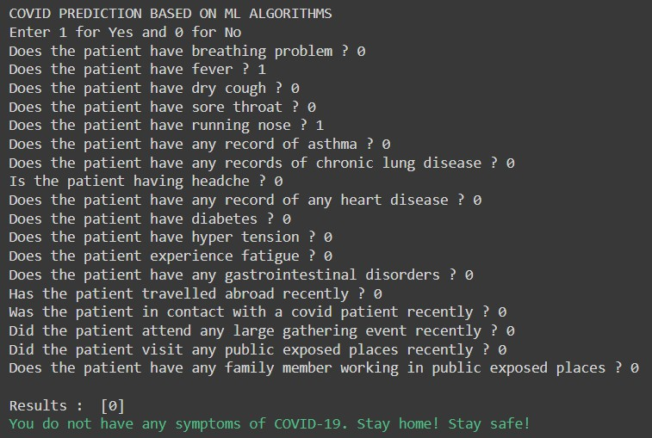
Fig. 13. Prediction model takes input from the user and gives a result - COVID Positive

- Individuals can quickly determine whether they are at risk of transmitting COVID-19 based on their symptoms.
- Medical practitioners can employ this test as a primary health assessment for COVID detection.
- Assisting businesses in limiting physical interaction with clients who may be infected with COVID-19;
Extra information or diagnoses from hospital records, per- sons who contracted the virus, COVID-19 survivors, patients under assessment, or management can all be included for future research. A software which can predict the severity of COVID-19 can indeed be deployed to provide further informa- tion about the steps that must be taken and the interventions that should be considered.
References
- Wu F, Zhao S, Yu B, Chen YM, Wang W, Song ZG, Hu Y, Tao ZW, Tian JH, Pei YY, Yuan ML, Zhang YL, Dai FH, Liu Y, Wang QM, Zheng JJ, Xu L, Holmes EC, Zhang YZ (2020) A new coronavirus associated with human respiratory disease in china. Nature 44(59):265–269 https://www.nature.com/articles/s41586-020-2008-3[1]

- Medscape Medical News, The WHO declares public health emergency for novel coronavirus (2020) https://www.medscape.com/viewarticle/924596[2]
- A. F. M. Batista, J. L. Miraglia, T. H. R. Donato and A. D. P. C. Filho, ”COVID-19 diagnosis prediction in emergency care patients: a machine learning approach”, medRxiv, 2020 https://www.medrxiv.org/content/10.1101/2020.04.04.20052092v2.full. pdf[3]
- M. R. H. Mondal, S. Bharati, P. Podder and P. Podder, ”Data analytics for novel coronavirus disease”, Informatics in Medicine Unlocked Elsevier, vol. 20, pp. 100374, 2020 https://www.researchgate.net/publication/342195015 Data analytics

for novel coronavirus disease[4]
- D. Goodman-Meza, A. Rudas, J. N. Chiang, P. C. Adamson, J. Ebinger et al., ”A machine learning algorithm to increase COVID-19 inpatient diagnostic capacity”, PLOS ONE, vol. 15, no. 9, pp. e0239474, 2020. https://www.ncbi.nlm.nih.gov/pmc/articles/PMC7508387/[5]
- P. Schwab, A. D. Schu¨tte, B. Dietz and S. Bauer, ”Clinical predictive models for COVID-19: systematic study”, J Med Internet Res, vol. 22, no. 10, pp. e21439, 2020.https://www.jmir.org/2020/10/e21439/[6]
- Y. Sun, V. Koh, K. Marimuthu, O. T. Ng, B. Young, S. Vasoo, M. Chan et al., ”Epidemiological and clinical predictors of COVID-19”, Clin Infect Dis, vol. 71, no. 15, pp. 786-792, Jul 2020. https://academic.oup.com/cid/article/71/15/786/5811426[7]
- Z. Meng, M. Wang, H. Song, S. Guo, Y. Zhou, W. Li et al., ”Development and utilization of an intelligent application for aiding COVID-19 diagnosis”, medRxiv, 2020. https://www.medrxiv.org/content/10.1101/2020.03.18.20035816v1[8]

